

PAYMENT AGREEMENT

# SIMON & SCHUSTER Worker Payment Agreement Contract

**All Workers Payment Agreement Contract (Online Remote Staffs and Permanent Staffs)**

# PARTIES

This Payment Agreement (hereinafter referred to as "**CONTRACT**") is entered into on the

by Mr./Mrs./Miss (hereinafter referred to as the "**Worker**"), with **SIMON & SCHUSTER** (hereinafter referred to as the "**Company**") (collectively referred to as the "**Parties**").

# AGREEMENT

The parties agree that the company is to pay the worker after completion and submission of project by following due instructions in accordance to the company terms and conditions

The parties agree that the company is to secure the amount to be received by the worker by creating a worker profile which would be he's/her payroll account with which payment can be withdrawn successfully to any preferred payment method available, by entering into this agreement where the amount of payment after project completion would definitely be paid by the company after successful creation of employee's worker profile with accordance to the terms and conditions provided below.

# TERMS AND CONDITIONS

 Project should be completed and submitted within the deadline given by the company

 Incomplete Work/Project would be accepted with the company's compensation for time spent (this option is only available in case of inevitable circumstances beyond the worker's control)

 Use of unauthorized third-party software/application is strictly prohibited, if necessary, kindly inform the management before prior use

 Make separate file for each document and name of every document file must correspond (**optional**)

 Complete project details would be sent to you on email along with needed files, documents, samples and technical instructions to start working on after successful enrollment due to confidential reasons (enrollment is **free** and strict obedience to technical instructions for every project detail would be greatly honored)

 You'll receive and submit project via email

 You’ll get your payment within 24 hours after project submission and processing of workers Permit Card

 All first-time workers are required to submit any government approved Id card and to follow due instructions to completely create, verify and activate their workers profile to enable us to process payment, note only the creation fee would be covered by the company

# DEFAULT

In case the "Worker" fails to comply and work by the above stated terms and conditions, the company has the right to make final decision prior to project payments, either worker gets a percentage of he's/her total payment or the otherwise. This Agreement shall be governed by and construed in accordance with the laws of the State Jurisdiction

In an event where any provision of this Agreement is found to be void and unenforceable by a court of competent jurisdiction. then the remaining provisions will remain to be enforced in accordance with the company's policy.

# RESOLUTION

Any dispute or difference whatsoever arising out of or in connection with this Agreement shall be submitted to (Arbitration/mediation, 'negotiation) in accordance with, and subject to the laws of court Jurisdiction

# ENTIRE AGREEMENT

This contains the entire agreement and understanding among the Parties hereto with respect to the subject matter hereof and supersedes all prior agreements. understandings, inducements and conditions. express or implied. oral or written. Of any nature whatsoever with respect to the subject matter hereof. The express terms hereof control and supersede any course of performance and/or usage of inconsistent with any of the terms hereof.

# WORKER DATA

First Name: Last Name: Country: Email Address: Date of Birth:

# SIGNATURE AND DATE

The Parties hereby agree to the terms and conditions set forth in this agreement and such is demonstrated throughout by their **signatures** below

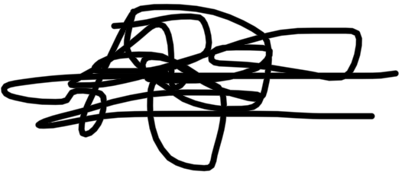

Sign (Worker) Sign (Management)